**IDS 462 STATISTICAL SOFTWARE FOR BUSINESS**

**HOMEWORK 2 – Part 1**

**TEAM MEMBERS**:

1. Harish Visweswaraiya
2. Balachandhar Chekka Narayanasame
3. Sriram Ravi
4. Vinodh Sankaran

**Problem 1.2**

**a) Create a SAS dataset using column input**

**Input**

00768155150

00272250240

00563240200

00170345298

**Code**

**/*Problem 1.2 (a) */**

data bmicalc;

input subj $1-3

height 4-5

wt_init 6-8

wt_final 9-11;

bmi_init=(wt_init/2.2)/((height*0.0254)**2);

bmi_final=(wt_final/2.2)/((height*0.0254)**2);

bmi_diff=bmi_final-bmi_init;

datalines;

00768155150

00272250240

00563240200

00170345298

;

**Output Data**

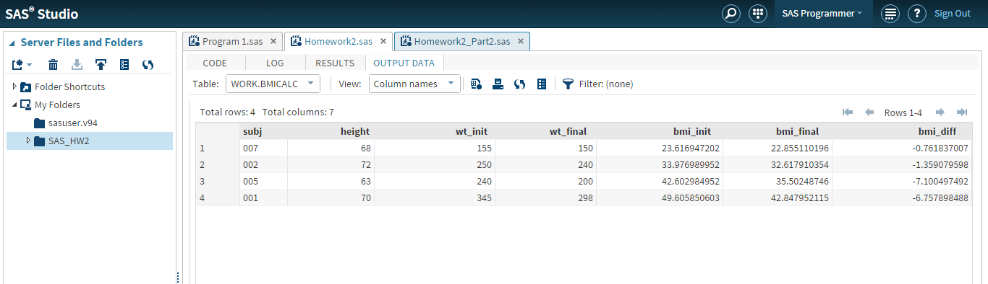

**b) Sort and Print the listing of the dataset based on subject**

**Code**

**/*Problem 1.2 (b) */**

proc sort data=bmicalc out=bmifinal; by subj; run;

proc print data=bmifinal (keep=subj height bmi_init bmi_final bmi_diff);

run;

**Output Data**

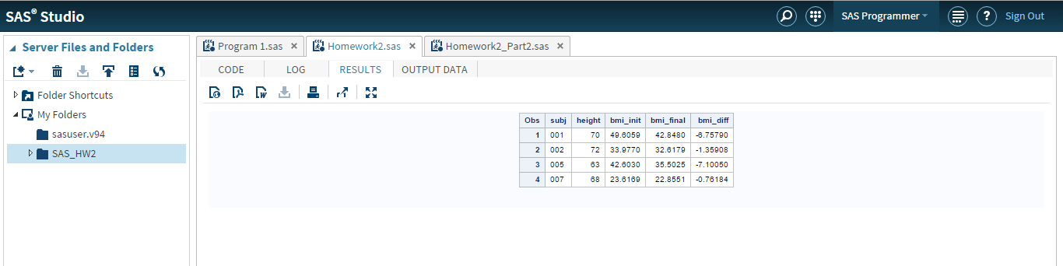

**Problem 1.10**

**Create a SAS data set to calculate the average rainfall for 3 months**

**Compute the descriptive statistics**

**Input**

Trenton 23 25 30

Newark 18 27 22

Albany 22 21 27

**Code**

**/*Problem 1.10 */**

data rain;

input city :$10.

rain_june

rain_july

rain_august;

average=mean(of rain_june,rain_july,rain_august);

percent_june=100*(rain_june/average);

percent_july=100*(rain_july/average);

percent_august=100*(rain_august/average);

datalines;

Trenton 23 25 30

Newark 18 27 22

Albany 22 21 27

;

proc sort data=rain out=rainsort; by city; run;

proc means data=rainsort(keep=rain_june rain_july rain_august) mean std clm maxdec=2;

run;

**Output Data**

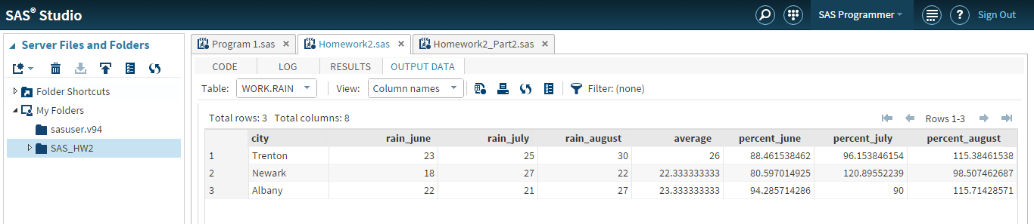

**Sort based on City**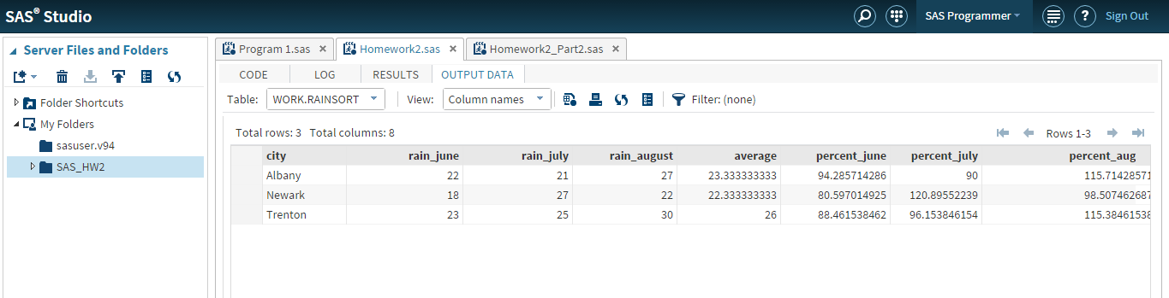

**Confidence Interval (95%)**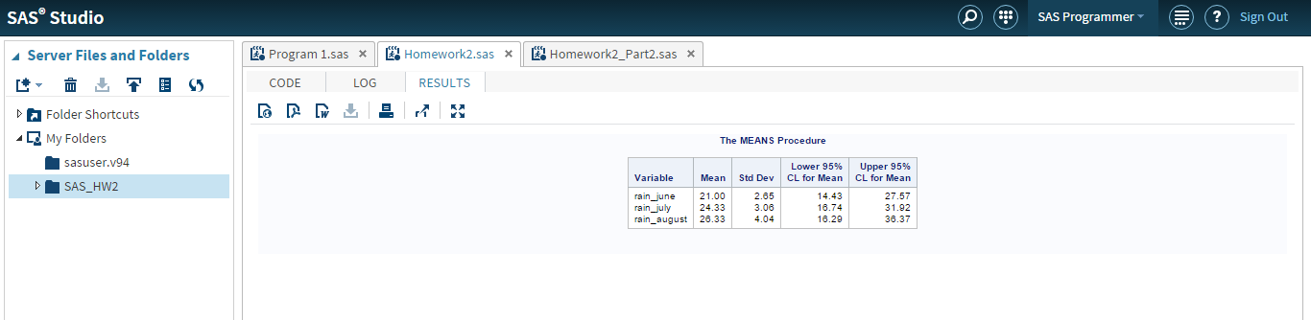

**Problem 2.2**

**Create a SAS data set to compute average Blood Pressure**

**Use Proc means to compute non missing values**

**Input**

001MW08013008010

002FW08811007205

003MB05018810002

004FB 10806801

005MW06812208204

006FB101 07404

007FW07810406603

008MW04811207006

009FB07719011009

010FB06616410610

**Code**

**/*Problem 2.2 */**

data clinic;

input id $1-3

gender $4

race $5

hr 6-8

sbp 9-11

dbp 12-14

n_proc 15-16;

avg_bp=dbp+(1/3*(sbp-dbp));

datalines;

001MW08013008010

002FW08811007205

003MB05018810002

004FB 10806801

005MW06812208204

006FB101 07404

007FW07810406603

008MW04811207006

009FB07719011009

010FB06616410610

;

proc means data=clinic(keep=sbp dbp avg_bp) n mean std clm median;

run;

**Output**

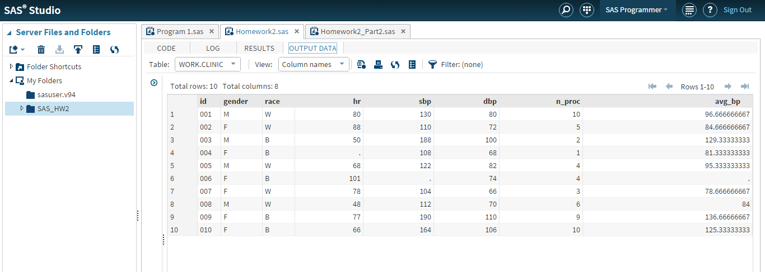

**Proc Means**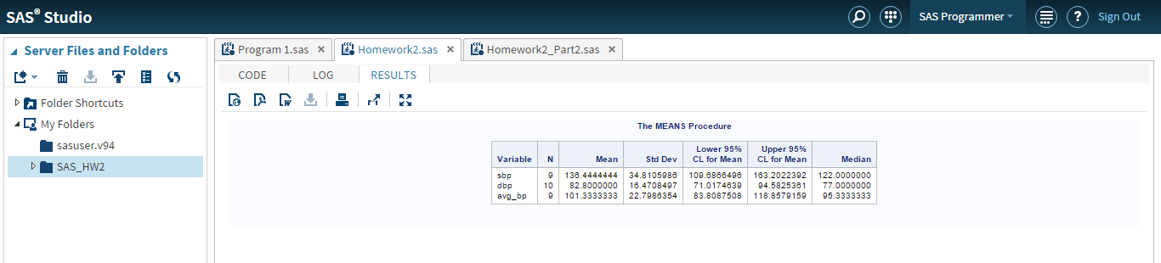

**Problem 12.2**

**Create a SAS data set to read patient details**

**Input**

10/21/1950,03MAY2004,M,Schneider

11/12/1944,05DEC2004,F,Strawderman

01/01/1960,25APR2004,M,Smith

**Code**

/*Problem 12.2 */

data patient_details;

infile datalines delimiter=',';

input date_of_birth :mmddyy.

visit_date :date.

gender :$1.

last_name :$10.;

format date_of_birth mmddyy10. visit_date date9.;

datalines;

10/21/1950,03MAY2004,M,Schneider

11/12/1944,05DEC2004,F,Strawderman

01/01/1960,25APR2004,M,Smith

;

**Output Data**

